DESIGN YOUR STYLE

By:

**Eeti Jain(11BCE027),**

**Kavya Jha(11BCE041),**

**Yamini Rathod(11BCE078)**

Guide:

**Prof. Tarjni Vyas**



DEPARTMENT OF COMPUTER SCIENCE AND ENGINEERING

INSTITUTE OF TECHNOLOGY, NIRMA UNIVERSITY

AHMEDABAD-382481

November,2014

DESIGN YOUR STYLE

**Minor Project**

Submitted in partial fulfillment of the requirements

For the degree of

**Bachelor of Technology in Computer Science And Engineering**

By:

**Eeti Jain(11BCE027),**

**Kavya Jha(11BCE041),**

**Yamini Rathod(11BCE078)**

Guide:

**Prof. Tarjni Vyas**



DEPARTMENT OF COMPUTER SCIENCE AND ENGINEERING

INSTITUTE OF TECHNOLOGY, NIRMA UNIVERSITY

AHMEDABAD-382481

November,2014

**Certificate**

This is to certify that the Minor Project entitled **Design Your Style** submitted by **Eeti Jain** (11BCE027),**Kavya Jha**(11BCE041) and **Yamini Rathore**(11BCE078), towards the partial fulfillment of the requirements for the degree of Bachelor **of Technology in Computer Science and Engineering of Nirma University, Ahmedabad** is the record of work carried out by us under my supervision and guidance. In my opinion, the submitted work has reached a level required for being accepted for examination. The results embodied in this project, to the best of my knowledge, haven't been submitted to any other university or institution for award of any degree or diploma.

Mrs. Tarjni Vyas, Dr. Sanjay Garg

Assistant Professor, Head of Department,

Dept. of Computer Science Dept. of Computer Science

Institute of Technology, Institute of Technology,

Nirma University, Nirma University,

Ahmedabad Ahmedabad

**Acknowledgment**

We would like to sincerely thank my guide, Prof. Tarjni Vyas, Assistant professsor, Department of Computer Science and Engineering, Institute Of Technology, Nirma University, Ahmedabad for patiently explaining the concepts of the project and for her valuable guidance and continuous encouragement throughout the course of our Minor Project.

We are also thankful to Dr. Sanjay Garg, Head of Department, Department Of Computer Science and Engineering, Institute of Technology, Nirma University, Ahmedabad and to Dr. Ketan Kotecha, Director, Institute of Technology for giving us this chance to work in this project and for encouraging students like us to come up with this type of innovative projects.

We are also grateful to Prof. Pooja Shah for her continuous help whenever we got stuck anywhere and helped us to reach this level of completion and Prof. Vishal Parikh and Prof. Anitha Ashokan for their continuous guidance. Last but not the least; I would like to thank God for always being there for us.

- Eeti Jain

11BCE027

-Kavya Jha

11BCE041

-Yamini Rathore

11BCE078

**Abstract**

Design Your Style is a web portal where one can make their own designs and styles. It will help one in avoiding going to tailors for designing and stitching dresses. It is a system which helps in both ways, user can directly purchase cloth materials, readymade dresses or they can design their own dress , select their style and get it stitched by sitting at home. Only Internet access required. By following simple steps, one will be able to get one's dress ready at their place.

The Portal includes various modules. The Basic modules includes the Private Cart Facility by doing the registration, Selecting the readymade dresses which can be ordered directly and the Module for Designing Your own Dress. One can also upload their made designs, which can be accessed by others if they liked it. Along with this, one can see their designs on a dummy and select the appropriate design they like and select their preferable design and get it stitched. Portal also provide various payment options.

This portal will be helpful for Fashion Designers, Users and those who want to keep fashion in their hand every time.

**Contents**

Acknowledgement 4

Abstract 5

1. Introduction 8
   1. Purpose 8
   2. How is our site different from other sites 9
   3. Intended Audience 9
   4. Product Scope 9
   5. Literature Review 10
2. UML Diagrams

2.1 Product Description 12

2.2 Use Case Diagrams 13

2.3 Sequence Diagrams 14

2.4 Class Diagram 15

1. Implementation 17
   1. Tools Used 17
      1. WAMP Server 17
      2. Prestashop 18
      3. Adobe Flash CS6 19
      4. Adobe Photoshop CS6 19
   2. Shopping Module 20
   3. Stitching Module 21
   4. Login Module 26
   5. Miscellaneous 27
2. Results and Conclusion 29
   1. Results 29
   2. Conclusions 29
3. Future Scope 30
4. References 31

**List of Figures**

1. Comparison between Magento and Prestashop 10

2. Use Case diagram of the project 12

3. Sequence Diagram of the Portal 13

4. Class Diagram of the Project 14

5. Work Flow of the Project 19

6. Snippet showing Shopping module 19

7. Snippet for choosing the fabric 20

8. Snippet for choosing the neck pattern 21

9. Snippet of choosing cloth for the border pattern 21

10. Snippet of choosing border pattern 22

11. Choose the sleeve pattern 23

12. Confirm the Design Pattern 23

13. Take snapshot and Upload the image 24

14. No Sample design shown before any uploads 25

15. Sample design when an image is uploaded 25

16. Sign In Page 26

17. Login Page 26

18. Miscellaneous example: Site map 27

**Chapter 1**

**Introduction**

**1.1 Purpose**

Fashion Style Clothing is a web portal where one can shop Indian dresses as well as can design their own dresses with the facility provided for customization of fabrics and various patterns required for an Indian Kurti. Using this portal, one can avoid going to the tailor shop and get in discussion with them for designing the type of dress they want. Here they can design their dress according to their requirements and get to know on a dummy that how it looks, and if they wish they can order their customized design which we will deliver to them after getting it stitched.

This portal works in both ways, one is that the user can directly purchase cloth materials and readymade dresses, other is that they can design their dress by following few simple steps. The view provided to user of their design helps them to ensure about the looks of the design they selected for making the order.

Further, user will be able to upload their design on the portal which can be accessed by other users. This will help other people to know about the already ordered design and decide whether they want particular type of dress or want to design their own. Also, as this site can be accessed by Fashion Designers and the fashion freaks, few can show their made designs through the medium of this portal, which may help them to build contacts and go further in the fashion field.

**1.2 How our site is different from other sites?**

Our site provides users both the facility of purchasing the readymade dresses and design their own dress, while other sites such as Flipkart, Amazon, etc. provide the facility of only shopping the readymade dresses which are already designed. No customization is provided by any of the sites available.

We also show user the look of the dress as they design so that they can take appropriate decision whether to order it or not. None of the sites show this thing on a dummy.

One of the site namely, creyate.com which provide this type of facility, that is customized designing of clothes, is only designed for men shirts. Nothing yet has been designed for the Indian Kurtis.

**1.3 Intended Audience**

This portal is intended for the ones who want to shop Indian dresses and want to have complete hand over the dress they wear. This mainly deals with the users such as established Fashion designers, start up fashion designers, shopaholic, and the people who want to keep fashion in their hands.

**1.4 Product Scope**

The portal in it’s first form contains five main modules. The first module is meant for registration and login. The second is for displaying all the ongoing activities and a personal cart for each and every customer. The third module will provide the customer to choose and shop from readymade dresses and cloth materials. The fourth module or the stitching module will guide the customer in designing its own dress and show a glimpse of how it looks. The final module is for the payment and delivery options.

**1.5 Literature Review**

Various shopping websites is used to determine what all facilities are provided by them. Few examples of shopping websites are flipkart.com, amazon.com, fabindia.com, zabong.com, ebay.com . How their different modules are integrated with each other and what should be the perfect flow of the website for an user to get attracted is observed.

There are few websites such as chocolate, creyate.com[8] which provide customization of things such as chocolates and shirts respectively. There are no as such websites for women dresses which provide customization in hands of a women. Every website only provides the shopping facility of the already designed dress or the dresses already in the market.

Further, for selection of appropriate shopping cart solution two platform Magento[9] and Prestashop are compared which has the results as follows:

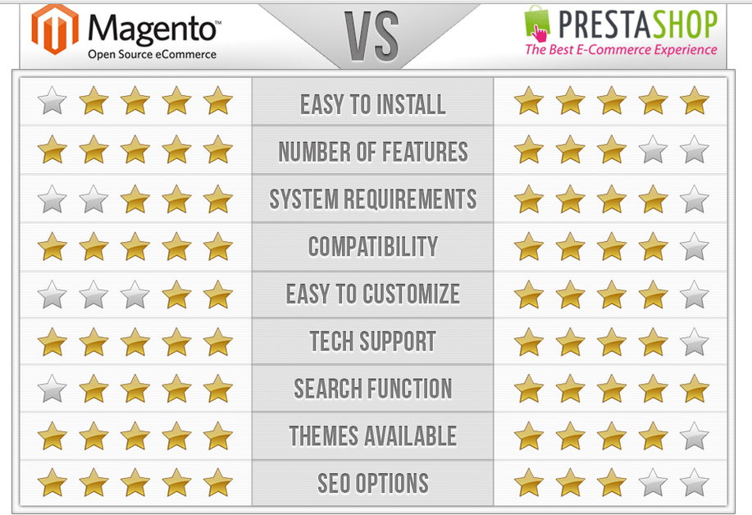

Figure : Comparison between Magento and Prestashop[10]

Both of these are open-source programs, they can be customized in many different ways. PrestaShop gives tons of features, makes site management easy, provides SEO benefits, gives users analytics and reporting and so much more. Over 125,000 online stores use PrestaShop, which makes finding help with the **program easy**.

Magento is, however, known as the leader in eCommerce shopping cart solutions. They provide a huge variety of features, tools and customization. Magento provides better SEO benefits than any other shopping cart on the market with targeted promotion and merchandising. They also allow for multiple payment and shipping option[10].

**Chapter 2**

**UML Diagrams**

**2.1 Product Description**

Fashion Design Clothing is a portal that helps one design their own dresses as well as one can shop readymade dresses which are provided by the company. Here one can design their dress according to their requirements and get to know on a dummy that how it looks, and if they wish they can order their customized design to be delivered at their place after getting it stitched.

This section includes the Use-Case Diagrams, Sequence Diagrams and Class Diagrams of the project. Use- Case Diagrams specifies the actors and the functionalities provided or done by them in the diagram with the link of include specified, if any revious action is to be action before performing any action.

Sequence Diagram specifies the sequence flow of the website which a customer should follow to be able to scan through the portal and do their required task. Class Diagram included the main classes of which the objects are composed to performed the various tasks designated to the portal. Diagrams have been shown in the section below.

**2.2 Use-Case Diagram**

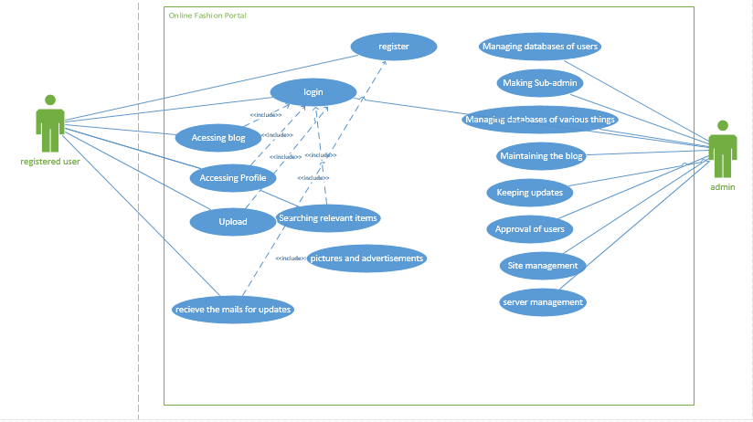

Figure : Use Case diagram of the project

**2.3 Sequence Diagram**

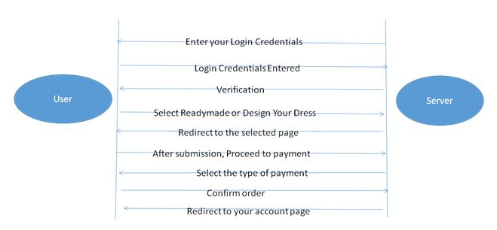

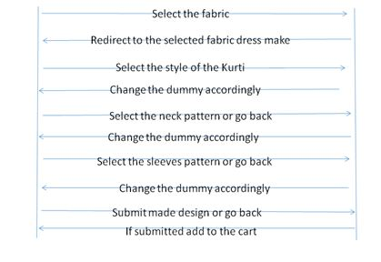

Figure : Sequence Diagram of the Portal

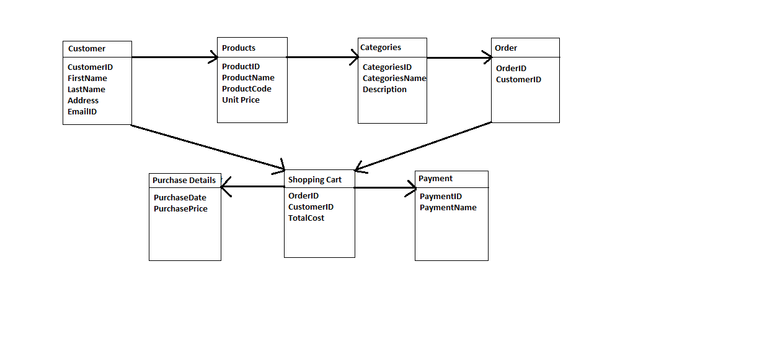**2.4 Class Diagrams**

Figure : Class Diagram of the Project

**2.3.1 User Classes and Characteristics**

<**Customer>**

|  |  |
| --- | --- |
| **Representative** | Customer |
| **Description** | The person or organization using the design your style application |
| **Type** | The person is the technically sound to log in and place the required order and design the dresses |
| **Responsibilities** | The key responsibility of the user is to provide complete information about the order and himself and make the necessary payment |
| **Involvement** | He is the one using the system to place order |
| **Deliverables** | Complete information about order or design |

**<Manager>**

|  |  |
| --- | --- |
| **Representative** | Manager |
| **Description** | Validates the customer and receives the corresponding order by using the system |
| **Type** | The person will be an expert having knowledge of using the system (hardware and software) and other features. |
| **Responsibilities** | The key responsibilities is to handle the log in account and the activity of other users and keep information about the graphs and data. He also has to take care of the entire database. |
| **Involvement** | He is the one using the entire system and also giving its review. |
| **Deliverables** | User will produce the log in account and can give permission rights. He generates the market analysis report. |

**Chapter 3**

**Implementation**

**3.1 Tools Used**

**3.1.1 WAMP Server**

WAMP[5], an acronym for Windows Apache MySQL and PHP is a Windows Web development Environment for personal webhosting. It allows one to create webs applications using Apache2, PHP and MySQL Database. Alongside, PHPMyAdmin allows to manage our databases easily.

The most important part of the WAMP package is Apache which is used to run the web server within windows. By running a local Apache WAMP server a web developer can test web pages without publishing them.

WAMP also includes MySQL and PHP which are the two of the most common technologies used for creating dynamic websites. MySQL is a high speed database while PHP is a scripting language that can be used to access data from the database.

Our website runs on this server. the various functionalities of WAMP that have been used are:

* Managing server settings
* Accessing and managing logs
* Storing and managing Databases
* Switching online or offline i.e. giving access to everyone or only local host
* Server side scripting using PHP for transferring data

**3.1.2 Prestashop**

Prestashop[1] is a free, open source e-commerce solution. It supports payment gateways such as Direct Pay, PayPal, etc. via their respective APIs. The modules provided by Prestashop are written in PHP and based on the Smarty template engine. It provides with various built in features including unlimited product inventory management, layered navigation, analytics and reporting, unlimited currencies and return management. The modules provided by the Prestashop are in a standard format and can be customized according to the needs. The various modules are linked together to form a website. That is done by running PHP and JavaScript's on WAMP server and providing appropriate links. Prestashop has lot of great features not only for the front-end but also for the back-office.

Front Office Features :

* Feature Products(Top seller, new items, ...) on the homepage
* Build-in product-image zoom
* Customer subscription and user accounts
* Unlimited payment methods
* RSS Feeds

Back Office Features:

* Unlimited categories and subcategories
* Different currency settings and tax settings
* Customizable delivery status and notification
* SSL encryption
* Smarty Templating Engine

**3.1.3 Adobe Flash CS6**

Adobe Flash Professional[2] is a multimedia authoring program used to create content such as web applications, games and movies, and content for mobile phones and other embedded devices. It is frequently used to add interacting multimedia content to web pages. Flash manipulates vector and raster graphics to provide animation of text, drawings and still images. It can capture user input via mouse keyboard microphone and camera.

Flash applications and animation can be programmed using the object oriented language called Action Script. It makes the flash content accessible on various operating systems such as Windows, Linux, and is available free of charge for common web browsers as plug ins. In our project Flash is used to develop the stitching module.

**3.1.3 Adobe Photoshop CS6**

Adobe Photoshop[3] is a raster graphics editor developed and published by Adobe System for Windows. it can edit and compose rater images in multiple layers and supports masks and several color models including RGB, spot color, dual tone, etc.

It has limited abilities to edit or render text, vector graphics, 3D graphics and video. Photoshop is the premier photo editing tool. Whether working on a web page, PowerPoint presentation or a document to be printed it can be used to enhance images. It can be used for cropping images, compositing( putting several images together), ghosting images (for use as web page backgrounds), using layers, creating masks, applying filters and formatting text with effects.

**3.2 Work Flow**

Figure : Work Flow of the Project

**3.2.1 Shopping Module**

This module showcases the readymade designs sold by the company and adds them to the cart when selected. Products can be categorized according to various filters and also can be displayed according to most popular or best sellers. The products are maintained in MySQL databases and fetched according to the data mining algorithm applied. Its like any other shopping interfaces provided by sites.

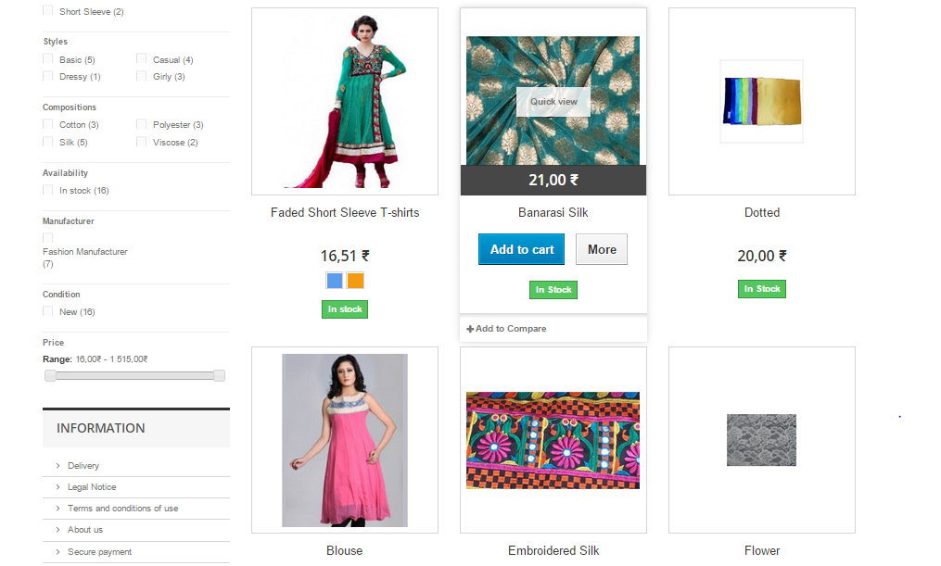

Figure : Snippet showing Shopping module

**3.2.2 Stitching Module**

This is the main feature of the website. It guides the user through simple steps how to design her own dresses. It has been implemented using Flash CS6 and coded using Action Script[6]. The first step is to choose from the variety of fabrics provided to design the dress. After selecting the fabric the user is asked to either add that fabric to the cart or design the dress using it. After that it enters the stitching module.

The module is made up of multiple swf files linked together. The first swf asks to choose a Kurti style (Umbrella, Straight, Anarkali).

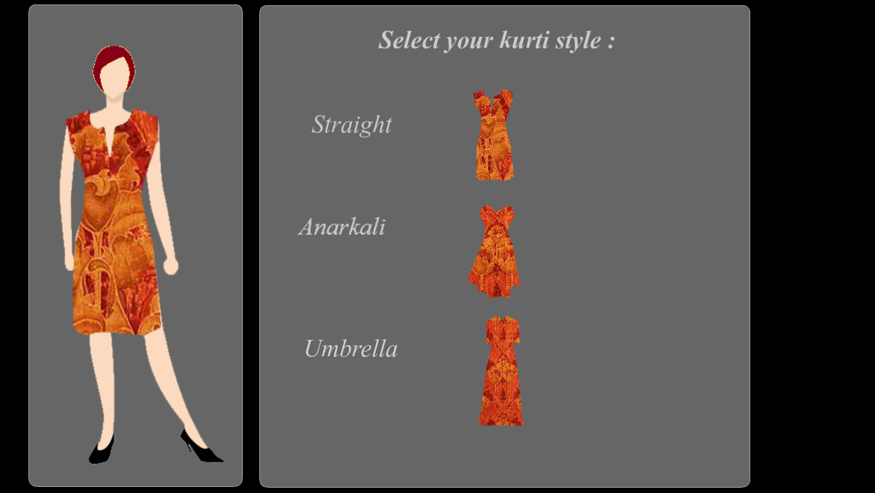

Figure : Snippet for choosing the fabric

It then asks the user to choose a neck pattern and border pattern.

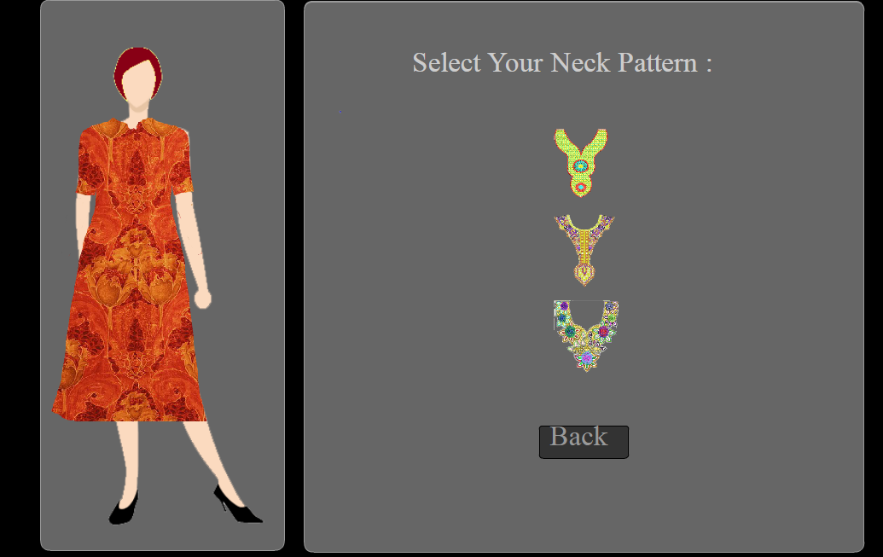

Figure : Snippet for choosing the neck pattern

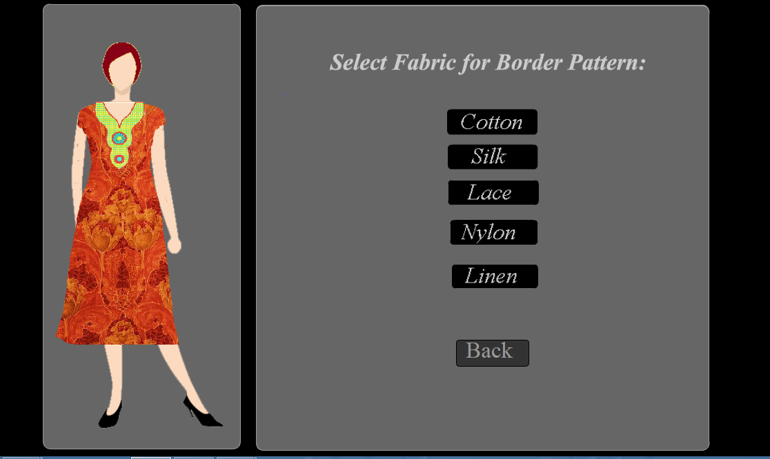

Figure : Snippet of choosing cloth for the border pattern

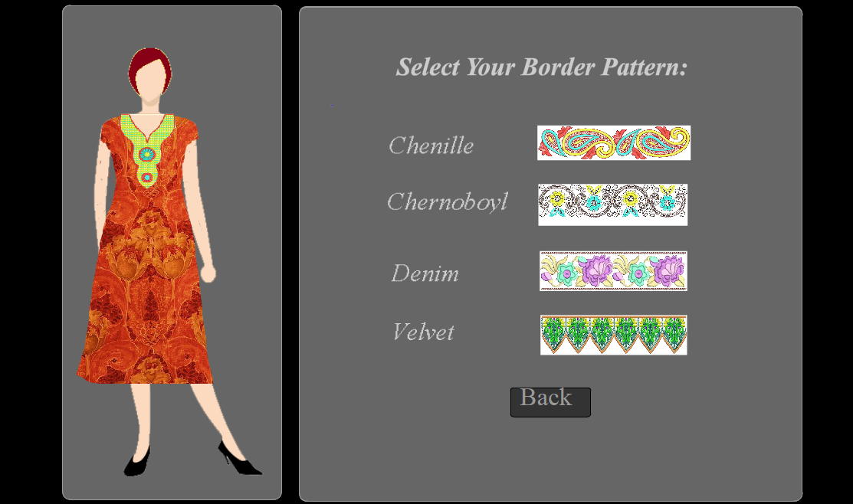

Figure : Snippet of choosing border pattern

Finally the user has to choose the Sleeve style.

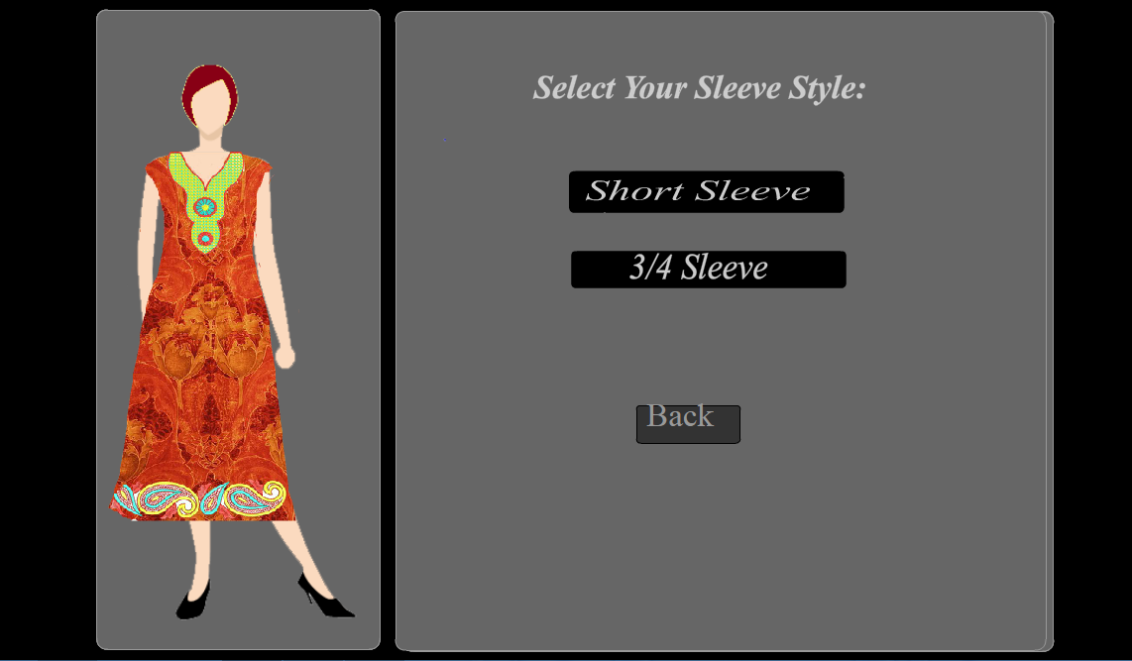

Figure : Choose the sleeve pattern

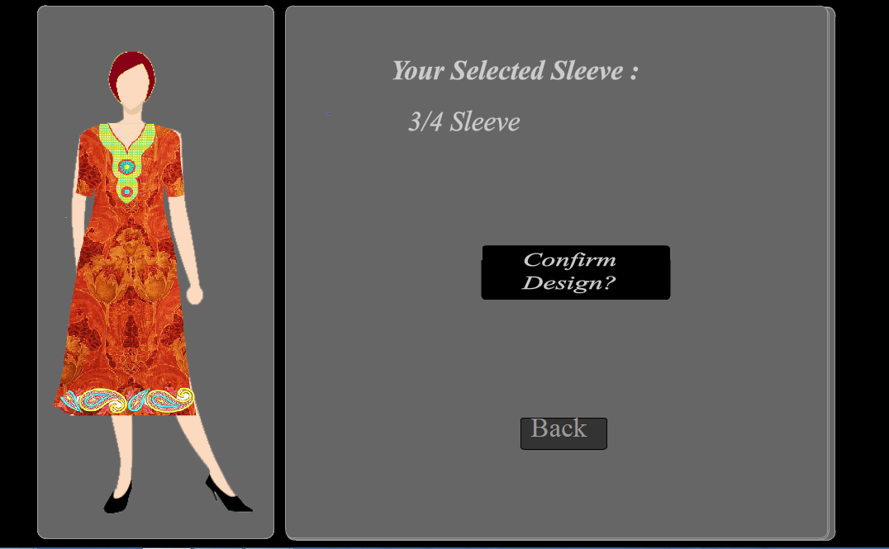

Figure : Confirm the Design pattern

Once it is done the user is asked for confirmation and the image is uploaded to the database.

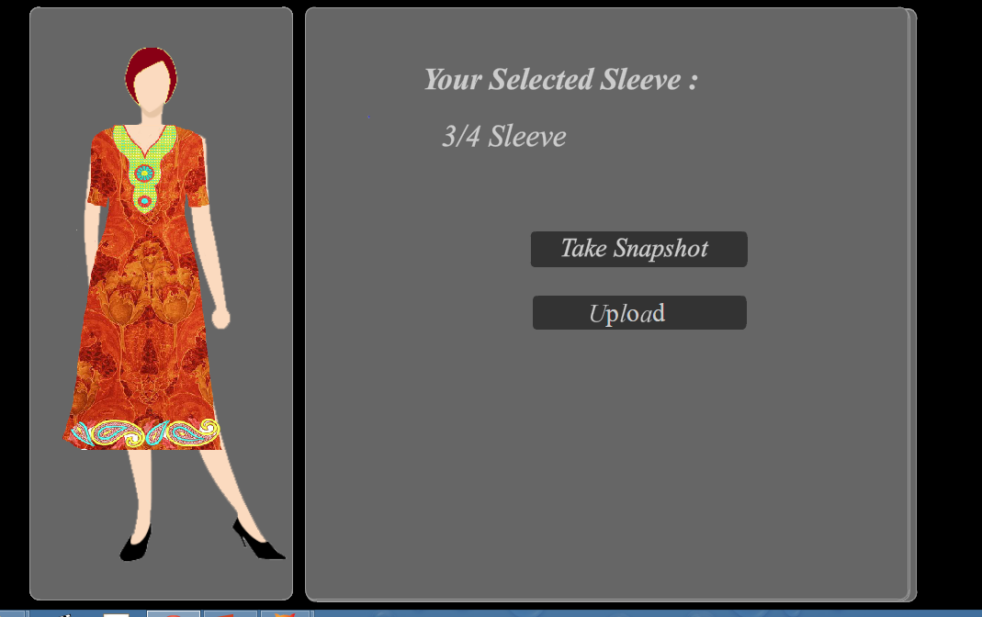

Figure : Take snapshot and Upload the image

Each swf transfers its data to the next swf. It's done using the array of images stored using Action Script.

A mouse click event has been attached to each and every button which causes the corresponding designs to get displayed on the dummy. The designs are made using Adobe Photoshop CS6. After the confirmation a snapshot of the image is taken. This is done using BitMapUploader library of the Action Script that converts the image in the swf into bits and stores it into a canvas. This canvas is then passed to a PHP script[7] along with the file name and the destination which converts it back into the image and uploads it into the database. Once the design has been created, it is displayed on the website as sample designs and can be ordered by another users if they want to.

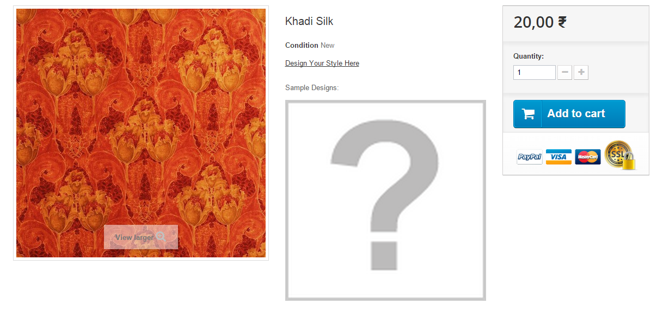

Figure : No Sample design shown before any uploads

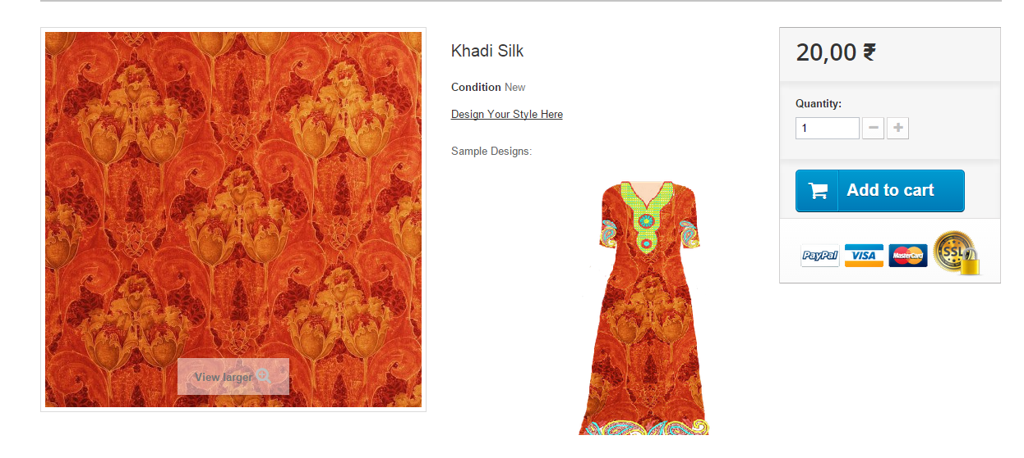

Figure : Sample design when an image is uploaded

**3.3 Login Module**

The user can sign in at any time while he is surfing through the sites. He can access his cart, go through his orders and design created. Login is compulsory before making a payment and final submission of the order. Once the user creates an account, his details are saved in a database along with his home address. The personal information saved are confidential and can only be accessed by the user or the admin itself. The first time users have to Sign up in order to create an account and place orders.

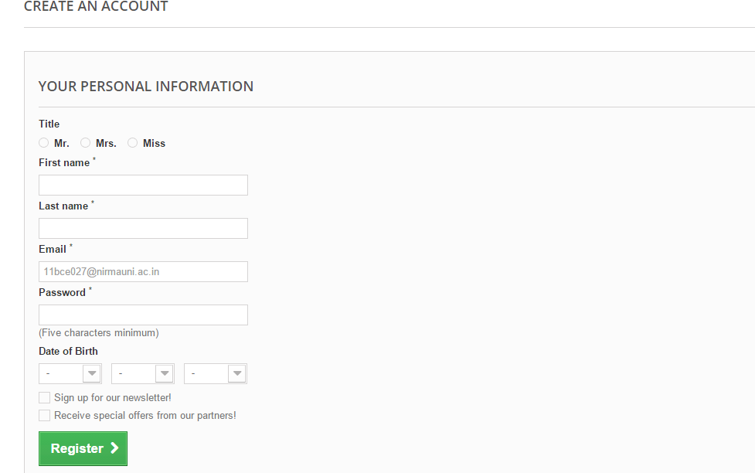

Figure : Sign in page

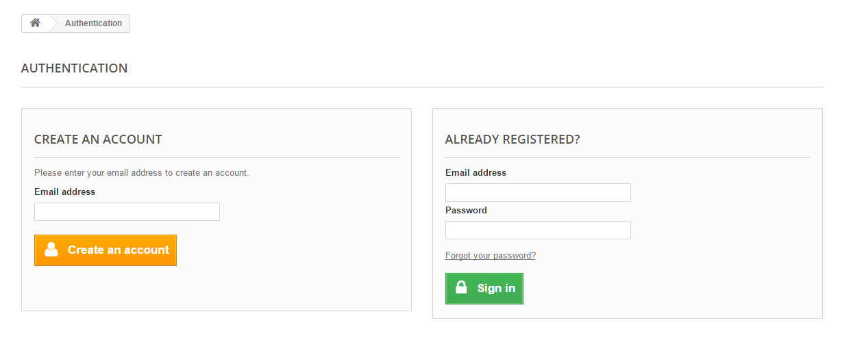

Figure : Login page

**3.4 Miscellaneous**

Users can send mail to the admin or the company in case of any complaints or inquiries. They can also subscribe to newsletter with their email Ids that will help them to remain up to date with any new additions to the collections. Every new product added will be shown as a separate list and the products can be filtered according to the best sellers. All the special or discount offers provided by the site can be displayed in one place. Also the site map of the whole website can be seen , helping in easier navigation.

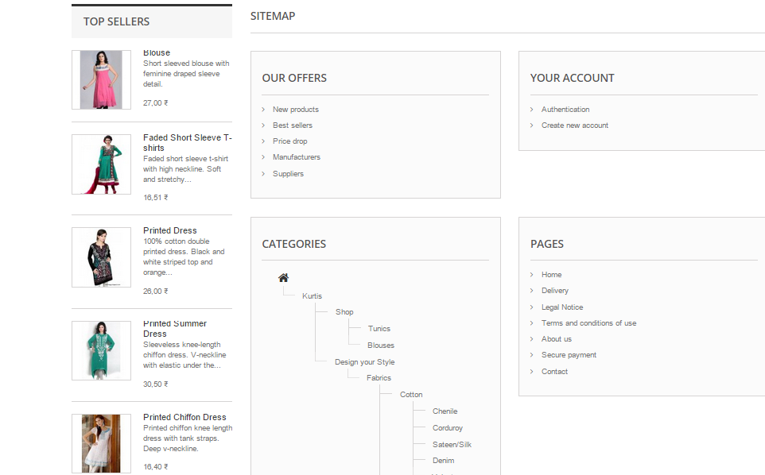

Figure :Miscellaneous example: Site map

**Chapter 4**

**Results and Conclusion**

**4.1 Results**

The result of this minor project is an almost completed portal which provides the facility to shop the Indian Kurtis and ,where one can design the type of dress one likes to wear. The Stitching module of the Implementation part is the main focus that is the module that enables the design your style concept of the portal Fashion Style Clothing.

Further, it also provide facility of seeing the designed dresses on dummy for getting the sense of how it actually looks after stitching.

**4.2 Conclusion**

The final conclusion drawn of the project is that by implementing the type of functionalities done for only one design, if be implemented for numerous design present, then it can be a successful portal on web where everyone from Fashion Designers, fashion freaks to normal users who want to change their dressing style with the change in fashion or who just want to shop something new will think of only one stop that is Fashion Style Clothing.

**Chapter 5**

**Future Scope**

**5.1 Future Scope**

In the future, this portal can be completed by integrating final result of new designed data with the payment module, where money of various objects that is included in the product design is counted for the final payment of the ordered design.

Further, currently this portal is working for only one sample design but it can be furnished so as to include multiple designs. After this both integration is done, we can make this portal public so as to get the appropriate outcome that is the purpose of this innovation.

**References**

[1] Prestashop (*www.prestashop.com/)*

[2] Adobe Flash (*get.adobe.com/flashplayer)*

[3] Adobe Photoshop (*www.adobe.com/in/products/photoshop.html)*

[4] Prestashop Tutorial (*www.1stwebdesigner.com/tutorials/beginners-guide-*

*prestashop/)*

[5] Wamp Server (*www.imatgedart.com/wiki/_media/serveis:formacio:cweb:*

*doc:wamp.pdf)*

[6] Actionscript tutorial (*www.actionscript.org/resources/categories/Tutorials/)*

[7] PHP tutorial (*www.w3schools.com/php/)*

[8] creyate.com (*www.creyate.com/)*

[9] Magento (*www.magentocommerce.com/download)*

[10] *https://www.udemy.com/blog/prestashop-vs-magento/*

[11] "An Introduction to Programming with ActionScript 3.0", [Patricia Cornez](http://www.google.co.in/search?tbo=p&tbm=bks&q=inauthor:%22Patricia+Cornez%22), [Trish Cornez](http://www.google.co.in/search?tbo=p&tbm=bks&q=inauthor:%22Trish+Cornez%22)

[12] "ActionScript Cookbook", Joey Lott

[13] "Advanced ActionScript with Design Patterns", Joey Lott, Danny Patterson

[14] "Prestashop 1.3 - Beginner's Guide", Theming

[15] "Adobe Flash CS4 Professional Classroom in a Book", Adobe Creative Team